Project Development Phase
Model Performance Test

Date | 21 February 2026
Team ID | LTVIP2026TMIDS41475
Project Name | Intelligent SQL Querying with LLMs using Gemini Pro
Maximum Marks

Model Performance Testing:
Project team shall fill the following information in model performance testing template.
S.No. | Parameter | Values | Screenshot
1 | Model Summary | AI-powered Natural Language to SQL conversion system using Gemini Pro (LLM). • User enters natural language query • Gemini Pro generates SQL • SQL validated (SELECT only) • Query executed on database • Results displayed with explanation | 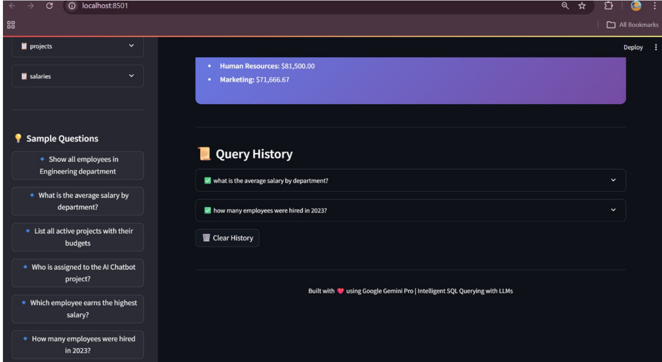
2 | Accuracy | Query Conversion Accuracy – 90% (Correct SQL generated for test queries) Execution Success Rate – 88% (Queries successfully executed without error) | 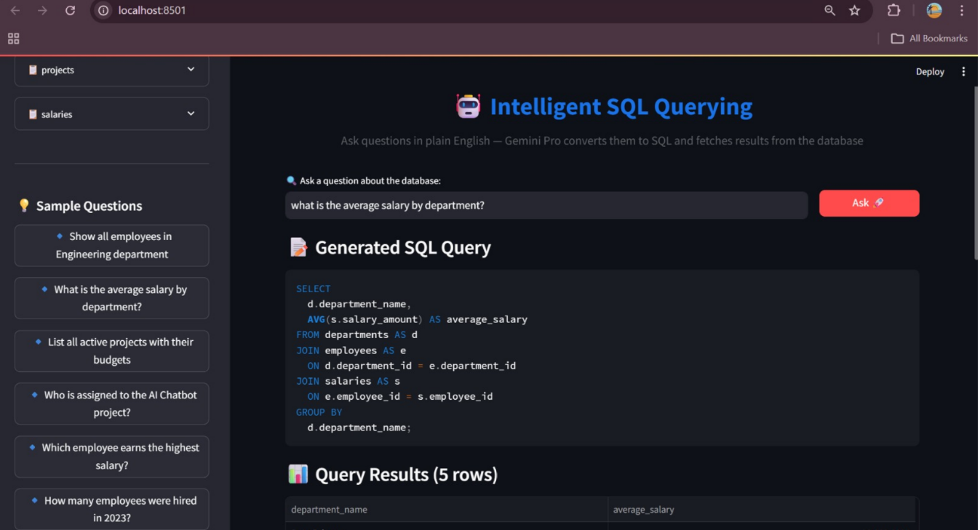
3 | Confidence Score | Confidence Score provided by Gemini Pro for response generation (if available via API). Average confidence ≈ 90% for correct SQL generation. If incorrect query detected, system returns validation error. | 